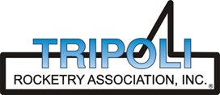
Tripoli Motor Testing Division
223 NC Highway 54 West
Chapel Hill, NC 27514
(919) 357 5681 (c)
October 18, 2021

Gary Rosenfield
RCS Rocket Motor Components, Inc.
2113 West 850 North Street
Cedar City, UT 84721

Dear Mr. Rosenfield,

The Aerotech I40N-P DMS motor was tested on October 16, 2021 and is in compliance with NFPA 1125. The motor is certified for hobby rocketry use by the members of the Tripoli Rocketry Association and all approving organizations with reciprocal certifying agreements.

Motor Manufacturer Aerotech Division, RCS Rocket Motor Components
Manufacturer’s Designation I40N-P DMS [end burner]
Propellant Warp Nine
TMT Nomenclature 375 I38

Diameter 1.51” 38.25 mm
Overall Length 7.99” 202.97 mm
No thrust ring on tested version

Loaded Mass 0.793 lb 359.87 g
Propellant Mass 0.434 lb* 197 g*
Burnout Mass 0.330 lb 149.82 g
* data provided by manufacturer

Burn time 9.951 ± 0.404 sec

Total Impulse 84.28 ± 2.43 lbf.s 374.90 ± 10.82 N.s
Max Impulse 22.85 ± 0.53 lbf 101.66 ± 2.34 N
Average Impulse 8.48 ± 0.54 lbf 37.73 ± 2.422.06 N
Number of Motors Tested 3

Nominal Measured
Delay Time Data n.a. n.a.

Casing Temp. [NFPA 1125 7.4.1] Passed

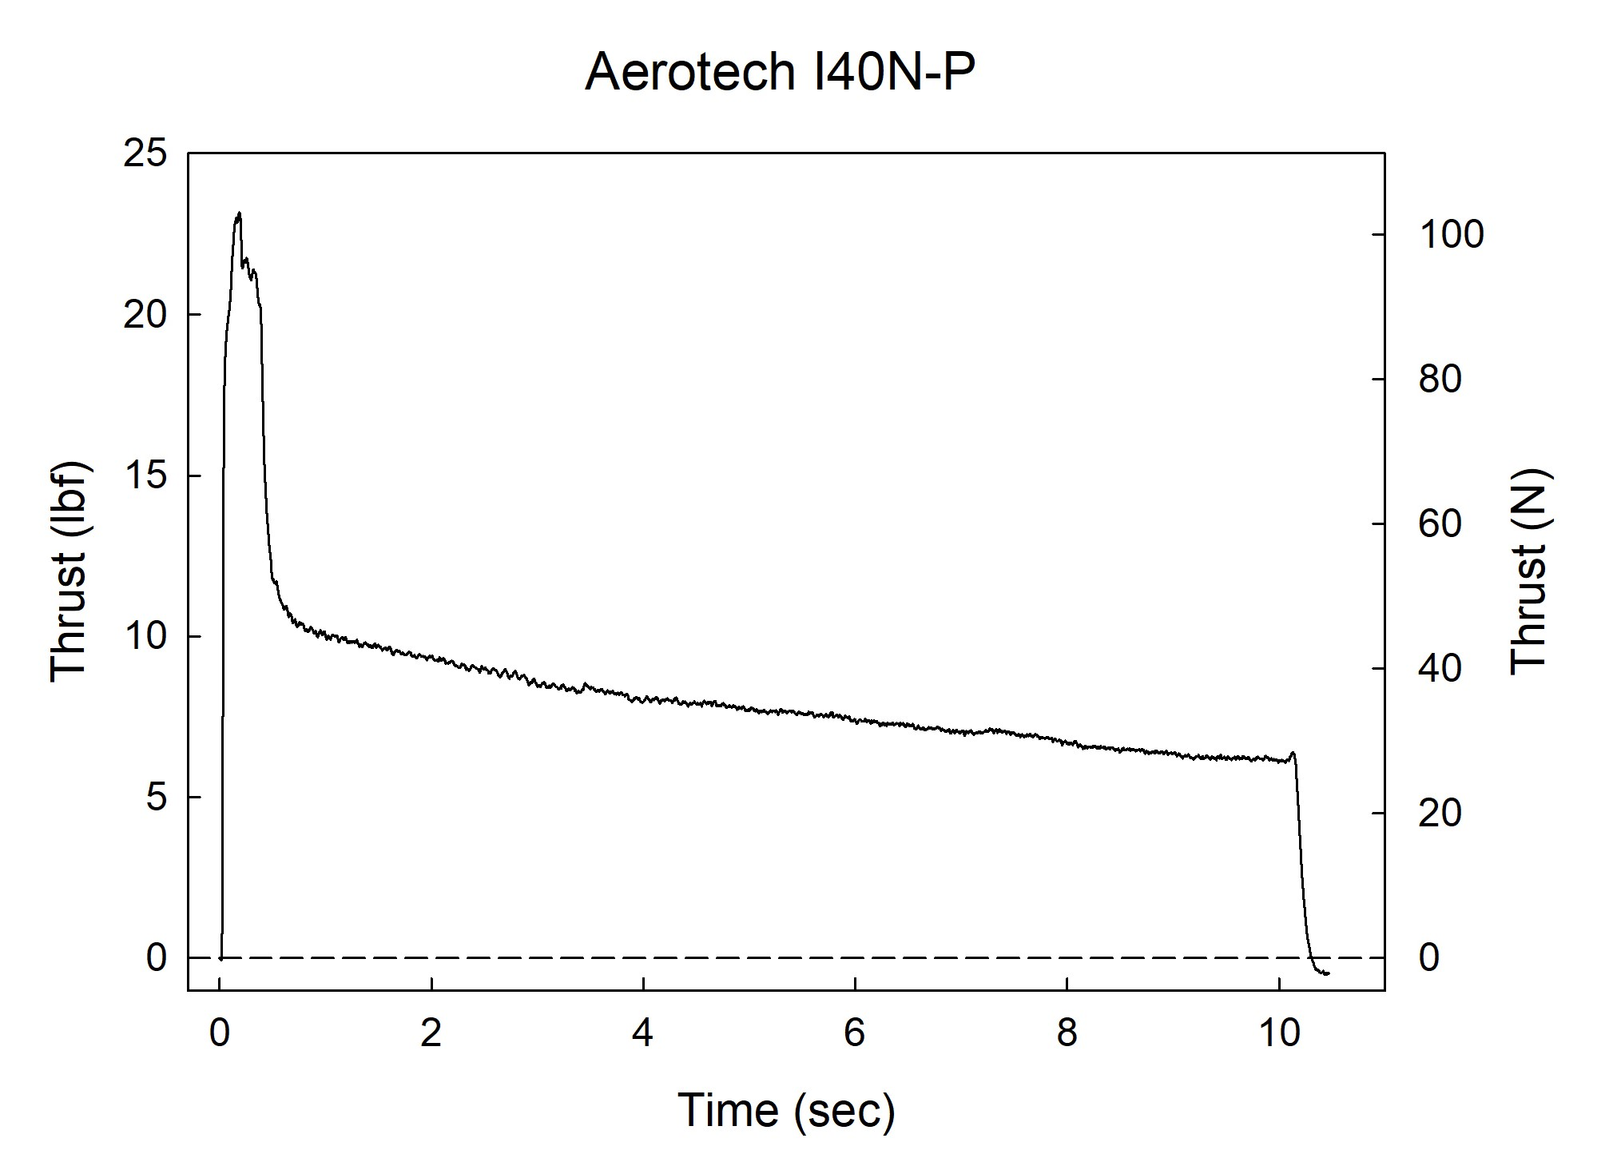

Sincerely,

Alan C. Whitmore
Chair, Tripoli Motor Testing

